1. **Question (1) Marks (7)**

Explain the operation of the speed control system and sketch a block diagram for model shown in Figure (1). Also

1. Write governing equation of physical model, also frequency equations.
2. Draw block diagram for this system.
3. Transfer function Y(s)/E( s )

**Fig. 1. Speed control system.**

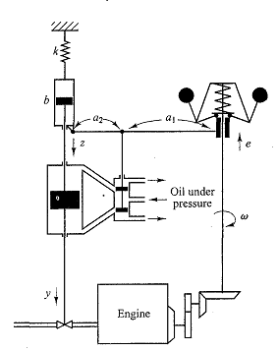

.

1. **Question (2) Marks (3)**

Consider a unity-feedback control system whose open-loop transfer function is



Discuss the effects that varying the values of K and B has on the steady-state error in unit-ramp response. Sketch typical unit-ramp response curves for a small value, medium value, and large value of K, assuming that B is constant